Normalization Practice – PG Example – DMIT 1508 Supplemental Learning Winter 2019

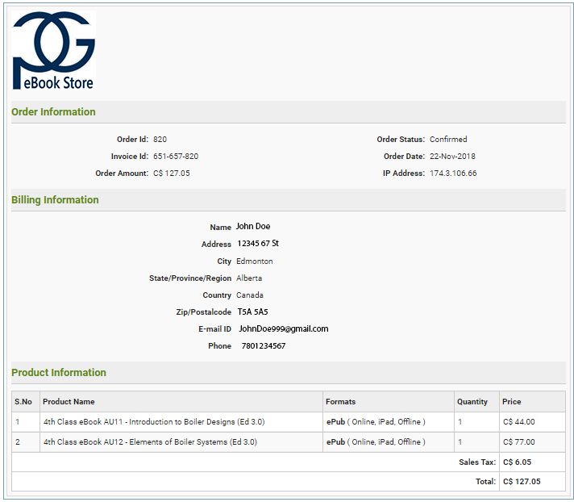

Notes:

* The last 3 digits of the Invoice ID always match the Order ID
* S.No is just a number given to the item in relation to this order not an item ID (a different order with three items would have 1, 2 and 3)

0NF

1NF

2NF

3NF

ERD